Task 1

1. Why This Scenario Requires Singleton
In the university examination system, all modules:
- Student Module
- Teacher Module
- Result Processing Module
- Admin Panel
must access a single Exam Configuration Manager that stores:
- Exam duration
- Grading policy
- Passing criteria
- Exam rules
Since these settings are global and shared, multiple instances may cause:
- Inconsistent rules
- Different grading policies across modules
- Incorrect result processing
- Loss of system integrity
Therefore, only one instance of the configuration manager must exist throughout the system.
The Singleton Pattern ensures:
- Only one object is created
- Global access to that object
- Controlled instantiati

2. C++ Implementation of Singleton Class
- Private constructor
- Private static instance pointer
- Public static getInstance() method
- Deleted copy constructor and assignment operator

#include <iostream>
#include <string>

using namespace std;

class ExamConfigManager {
private:
// Static instance pointer
static ExamConfigManager* instance;

// Configuration variables
int examDuration;
string gradingPolicy;
string passingCriteria;
string examRules;

// Private constructor
ExamConfigManager() {
examDuration = 180;
gradingPolicy = "Relative Grading";
passingCriteria = "40% minimum";
examRules = "No unfair means allowed";
}

public:
// Delete copy constructor and assignment operator
ExamConfigManager(const ExamConfigManager&) = delete;
ExamConfigManager& operator=(const ExamConfigManager&) = delete;

// Static method to get single instance
static ExamConfigManager* getInstance() {
if (instance == nullptr) {
instance = new ExamConfigManager();
}
return instance;
}

// Getters and Setters
int getExamDuration() { return examDuration; }
void setExamDuration(int duration) { examDuration = duration; }
string getGradingPolicy() { return gradingPolicy; }
void setGradingPolicy(string policy) { gradingPolicy = policy; }
string getPassingCriteria() { return passingCriteria; }
void setPassingCriteria(string criteria) { passingCriteria = criteria; }
string getExamRules() { return examRules; }
void setExamRules(string rules) { examRules = rules; }
};

// Initialize static member
ExamConfigManager* ExamConfigManager::instance = nullptr

3 Student Module
class StudentModule {
public:
void viewRules() {
ExamConfigManager* config = ExamConfigManager::getInstance();
cout << "Exam Rules: " << config->getExamRules() << endl;
}
};
Teacher Module
class TeacherModule {
public:
void viewGradingPolicy() {
ExamConfigManager* config = ExamConfigManager::getInstance();
cout << "Grading Policy: " << config->getGradingPolicy() << endl;
}
};
Admin Panel
class AdminPanel {
public:
void updateExamDuration(int duration) {
ExamConfigManager* config = ExamConfigManager::getInstance();
config->setExamDuration(duration);
}
};
Result Processing Module
class ResultProcessing {
public:
void calculateResult() {
ExamConfigManager* config = ExamConfigManager::getInstance();
cout << "Passing Criteria: " << config->getPassingCriteria() << endl;
}

4. Main Function Demonstration
int main() {

StudentModule student;
TeacherModule teacher;
AdminPanel admin;
ResultProcessing result;

// Admin updates duration
admin.updateExamDuration(120);

// All modules access same instance
student.viewRules();
teacher.viewGradingPolicy();
result.calculateResult();

cout << "Exam Duration: "
<< ExamConfigManager::getInstance()->getExamDuration()
<< " minutes" << endl;

return 0;
}

5. UML Diagram
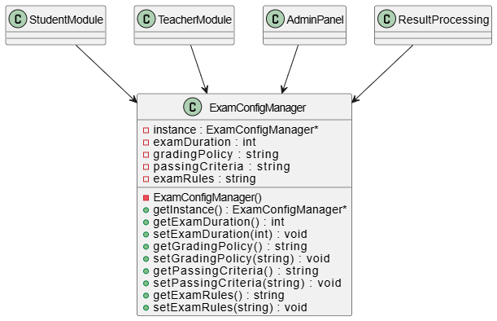

Task 2
FacadePattern Scenario: Smart City Service Portal

1. Identify problems in current system.
Based on the scenario :
- Publisher (Subject): Course (This entity holds the state, such as lectures, assignments, and grades).
- Observers (Subscribers):
  - Student
  - Teacher
  - AcademicAdvisor
  - Parent

2. Design a CityServiceFacade.
AND
3. Facade should provide simple methods like: λ requestService() λ trackRequest()

This code implements the CityServiceFacade as requested. It hides the complexity of the subsystems behind simple methods like requestService() and trackRequest()

#include <iostream>
#include <string>
#include <cstdlib> // For generating random IDs
using namespace std;

// ==============================
// Subsystem Classes (The Complex Parts)
// ==============================

class ComplaintRegistrationSystem {
public:
string registerComplaint(string serviceType) {
string id = "REQ-" + to_string(rand() % 10000);
cout << "[ComplaintSystem] Complaint registered for " << serviceType
<< ". Generated ID: " << id << endl;
return id;
}
};

class DepartmentRoutingSystem {
public:
void routeToDepartment(string serviceType) {
cout << "[RoutingSystem] Request routed to relevant " << serviceType << " department." << endl;
}
};

class SMSNotificationSystem {
public:
void sendSMS(string message) {
cout << "[SMS] Sending notification: " << message << endl;
}
};

class TrackingSystem {
public:
void track(string requestId) {
cout << "[TrackingSystem] Status for " << requestId << ": Processing in progress." << endl;
}
};

class BillingSystem {
public:
void generateBill(string serviceType) {
if (serviceType == "Water Supply Complaint") {
cout << "[BillingSystem] Service charge of $10 applied." << endl;
} else {
cout << "[BillingSystem] No charge for this service." << endl;
}
}
};

// ==============================
// Facade Class ( The Wrapper)
// ==============================

class CityServiceFacade {
private:
ComplaintRegistrationSystem* complaint;
DepartmentRoutingSystem* router;
SMSNotificationSystem* sms;
TrackingSystem* tracker;
BillingSystem* billing;

public:
CityServiceFacade() {
complaint = new ComplaintRegistrationSystem();
router = new DepartmentRoutingSystem();
sms = new SMSNotificationSystem();
tracker = new TrackingSystem();
billing = new BillingSystem();
}

~CityServiceFacade() {
delete complaint; delete router; delete sms; delete tracker; delete billing;
}

// Simplified Interface for requesting a service [cite: 448]
void requestService(string serviceType) {
cout << "\n--- Processing New Request: " << serviceType << " ---" << endl;

// The Facade handles the complex order of operations
string reqId = complaint->registerComplaint(serviceType);
router->routeToDepartment(serviceType);
billing->generateBill(serviceType);
sms->sendSMS("Your request " + reqId + " has been received and routed.");
}

// Simplified Interface for tracking [cite: 449]
void trackRequest(string requestId) {
cout << "\n--- Tracking Request ---" << endl;
tracker->track(requestId);
}
};

// ==============================
// Client Code
// ==============================

int main() {
// Client interacts ONLY with the Facade, not the subsystems
CityServiceFacade* portal = new CityServiceFacade();

// User requests a streetlight repair
portal->requestService("Streetlight Repair");

// User requests water supply help
portal->requestService("Water Supply Complaint");

// User tracks a request
portal->trackRequest("REQ-4052");

delete portal;
return 0;
}

4. Showhowfacade hides complexity.
If the city decides to change the SMSNotificationSystem to a new EmailNotificationSystem in the future, we only need to change the code inside the CityServiceFacade class. The Client code (the main function or the mobile app) remains completely untouched. This decoupling makes the system much easier to maintain and upgrade without breaking the user interface.

5. DrawUMLdiagram.
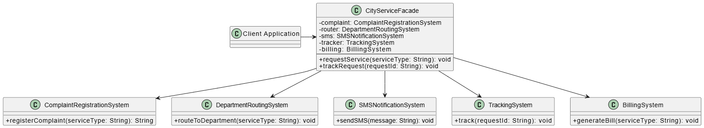

6. Explain how facade helps future upgrades.
The Facade pattern decouples the subsystems from the client code.
- Scenario: If the city decides to replace the SMSNotificationSystem with a new EmailNotificationSystem in the future.
- Benefit: We only need to update the code inside the CityServiceFacade class.
- Result: The Client code (e.g., the mobile app or main function) remains completely untouched and does not break.
Task 3
Observer Pattern Scenario: E-Learning Platform

1. Identify publisher and observers.
Publisher (Subject): The E-Learning Platform or a specific Course. It holds the state and triggers events like "new lecture" or "grades released".
Observers (Subscribers): Students, Teachers, Academic Advisors, and Parents.

2. Design an Observer system. AND
3. Allow dynamic subscription/unsubscription. AND
4. Implement at least two subscriber types.

# include <iostream>
# include <vector>
# include <string>
# include <algorithm>
using
namespace
std;
// Observer
Interface
class ISubscriber {
public:
virtual
void
update(const
string & message) = 0;
};
// Concrete
Subscriber
1[cite: 534]
class Student: public
ISubscriber
{
private:
string name;
public:
Student(string
n): name(n)
{}
void
update(const
string & message) override
{
cout << "[Student " << name << " Notification] " << message << endl;
}
};
// Concrete
Subscriber
2[cite: 534]
class Parent: public
ISubscriber
{
private:
string name;
public:
Parent(string
n): name(n)
{}
void
update(const
string & message) override
{
cout << "[Parent " << name << " Notification] " << message << endl;
}
};
// Publisher
Class[cite: 526, 532]
class Course {
private:
vector < ISubscriber * > subscribers; //
Dynamic
list[cite: 531]
string
courseName;
public:
Course(string
name): courseName(name)
{}
// Dynamic
subscription[cite: 532, 707]
void
subscribe(ISubscriber * s)
{
subscribers.push_back(s);
cout << "New subscriber added to " << courseName << "." << endl;
}
// Dynamic
unsubscription[cite: 532, 707]
void
unsubscribe(ISubscriber * s)
{
subscribers.erase(remove(subscribers.begin(), subscribers.end(), s), subscribers.end());
cout << "Subscriber removed from " << courseName << "." << endl;
}
// Notify
all
subscribers[cite: 529, 532]
void
notifySubscribers(const
string & event) {
cout << "\n--- System Event: " << event << " ---" << endl;
for (ISubscriber * s : subscribers)
{
s->update(courseName + ": " + event);
}
}
// Business
Logic
generating
events[cite: 532]
void
uploadLecture(string
topic) {
notifySubscribers("New lecture uploaded on " + topic);
}
void
releaseGrades()
{
notifySubscribers("Grades have been released!");
}
};
int
main()
{
Course
oopCourse("Object Oriented Programming");
Student * s1 = new
Student("Ali");
Parent * p1 = new
Parent("Mr. Khan");
// Dynamic
subscriptions[cite: 707]
oopCourse.subscribe(s1);
oopCourse.subscribe(p1);
oopCourse.uploadLecture("Design Patterns");
oopCourse.releaseGrades();
// Dynamic
unsubscription[cite: 707]
oopCourse.unsubscribe(p1);
oopCourse.uploadLecture("SOLID Principles"); // Parent
won
't get this
delete
s1;
delete
p1;
return 0;
}

5. Draw UMLdiagram.
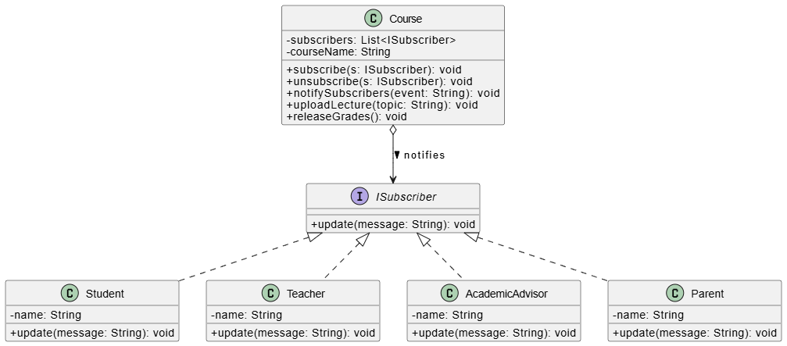

6. Explain what happens if Observer is not used.
Without the Observer pattern, the Course class would need to hardcode the notification logic for every user type (e.g., calling student.notify(), parent.notify(), teacher.notify() directly inside the uploadLecture method). This makes the system tightly coupled, rigid, and violates the Open/Closed Principle, as adding a new user type like "Academic Advisor" would require modifying the Course class directly.

Task 4
Combined Design Challenge (Event Management Platform)

1. Identify where each pattern applies.
Singleton Pattern: Applied to the "Payment Gateway Config". This ensures all payment transactions across the platform use the exact same API keys and security settings, preventing configuration mismatches.
Facade Pattern: Applied to the "Simplified booking interface". It will wrap the complex interactions between Registration, Payment Processing, and Notifications.
Observer Pattern: Applied to "Notify users of event updates". Registered users act as subscribers who get notified when event rules, times, or venues change.

2. Design system architecture.
The Client interacts exclusively with the EventBookingFacade.
The EventBookingFacade orchestrates calls to RegistrationSystem, PaymentSystem, and EventManager (Publisher).
The PaymentSystem fetches its global settings by calling PaymentConfig::getInstance() (Singleton).
The EventManager holds a list of User objects (Observers) and notifies them of changes via the update() interface.

3. Draw UMLdiagram.

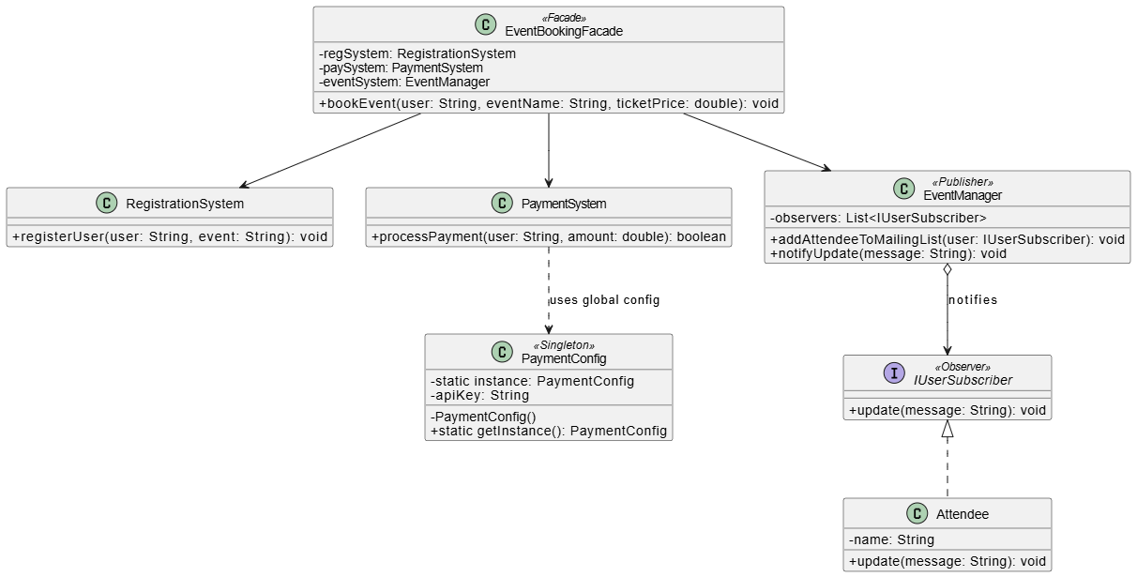

4. Provide sample code for one pattern.
#include <iostream>
#include <string>
using namespace std;
// Subsystem 1: Registration
class RegistrationSystem {
public:
void registerUser(string user, string event) {
cout << "[Registration] " << user << " registered for " << event << endl;
}
};
// Subsystem 2: Payment (Assumes Singleton is used inside)
class PaymentSystem {
public:
bool processPayment(string user, double amount) {
cout << "[Payment] Processed $" << amount << " for " << user << " using global config." << endl;
return true;
}
};
// Subsystem 3: Event Management (Acts as Publisher for Observers)
class EventManager {
public:
void addAttendeeToMailingList(string user) {
cout << "[Event System] Added " << user << " to the observer notification list." << endl;
}
};
// Facade Class [cite: 394, 721]
class EventBookingFacade {
private:
RegistrationSystem* regSystem;
PaymentSystem* paySystem;
EventManager* eventSystem;
public:
EventBookingFacade() {
regSystem = new RegistrationSystem();
paySystem = new PaymentSystem();
eventSystem = new EventManager();
}
~EventBookingFacade() {
delete regSystem; delete paySystem; delete eventSystem;
}
// Simplified booking interface
void bookEvent(string user, string eventName, double ticketPrice) {
cout << "\n--- Starting Booking Process for " << user << " ---" << endl;
regSystem->registerUser(user, eventName);
if (paySystem->processPayment(user, ticketPrice)) {
eventSystem->addAttendeeToMailingList(user);
cout << "Booking successful! Interface handled all subsystem complexities." << endl;
}
}
};
int main() {
EventBookingFacade bookingPortal;
bookingPortal.bookEvent("Sarah", "Tech Conference 2024", 150.00);
return 0;
}

5. Justify design decisions.
Using Singleton for the payment config prevents multiple instances from overriding sensitive API credentials or charging rules.
Using Facade shields the front-end application from needing to know the correct sequence of registering, billing, and subscribing a user.
Using Observer allows the platform to broadcast emergency updates (like a venue change) to thousands of attendees without tightly coupling the user objects to the event management logic.

